Fwd: User management - Assignment
1) Create user "nikhil" with home directory set as "/home/nikhil"
a) nikhil user should have "/bin/sh" shell for his environment
b) His password should expire in 9 days and 2 days before password expiry, he should get warning. User account must expire in 1 month from creation date
c) Give him root privileges to start/stop cron daemon.
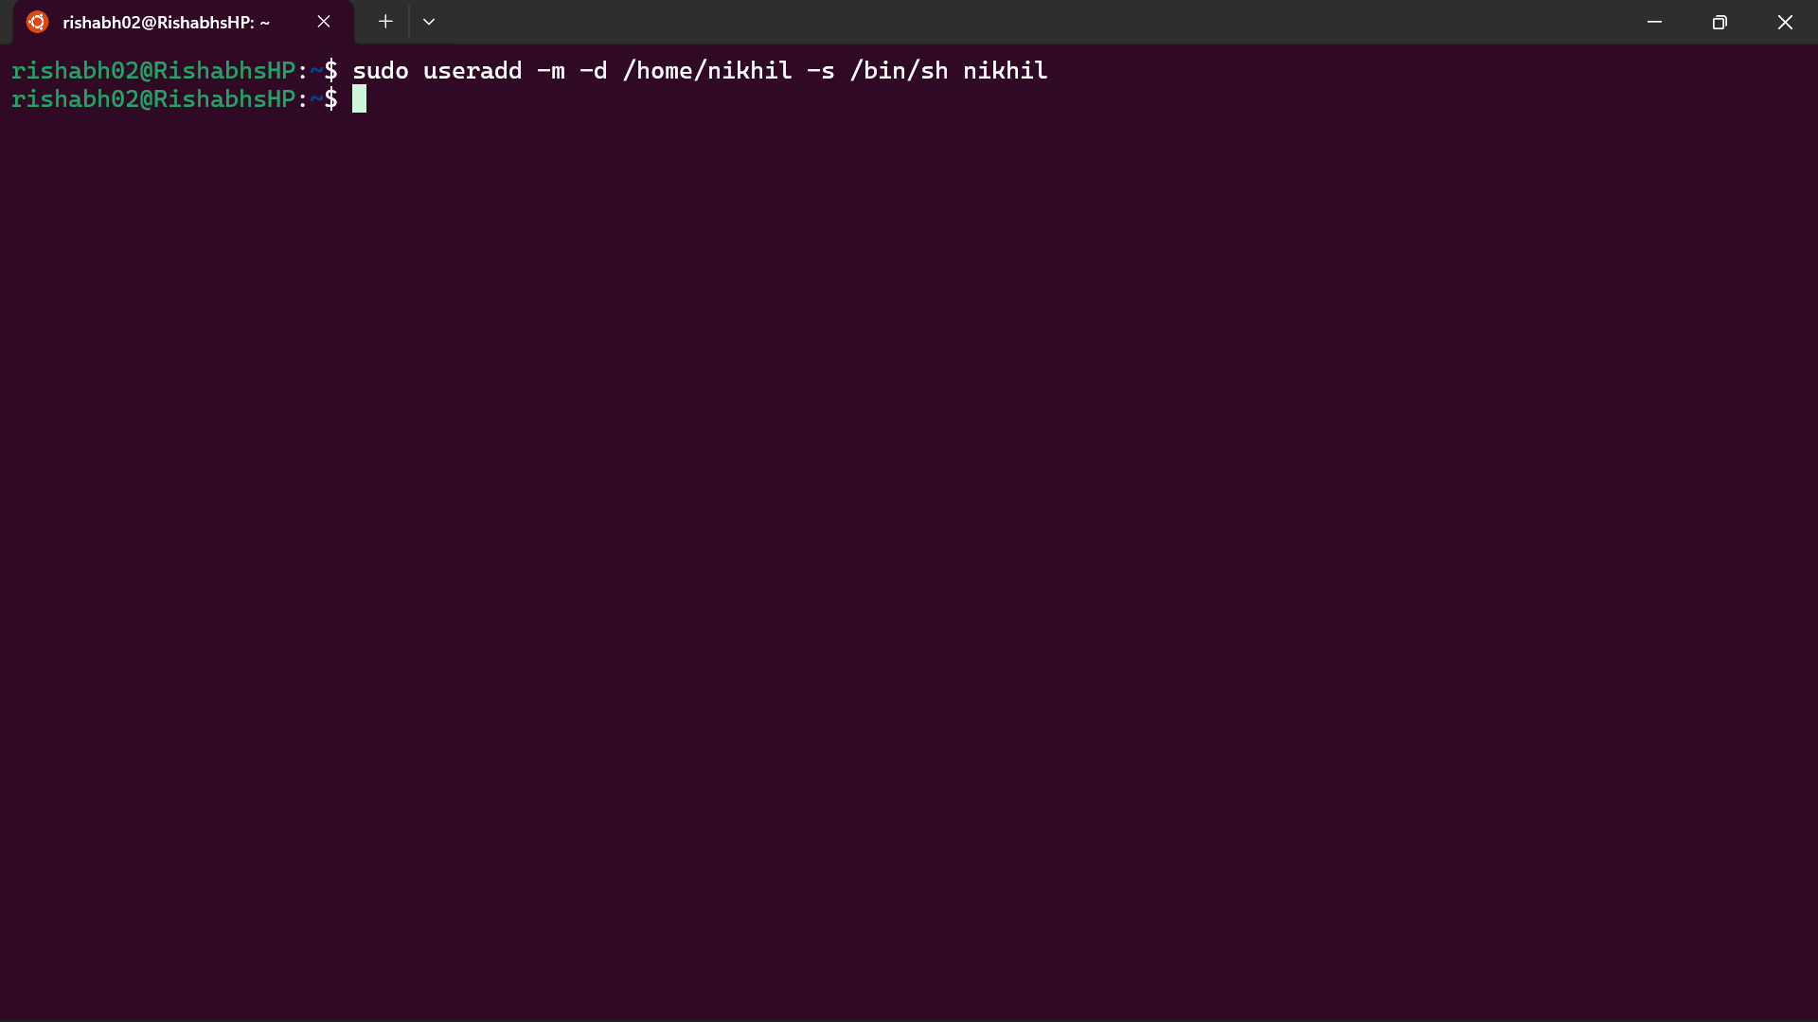

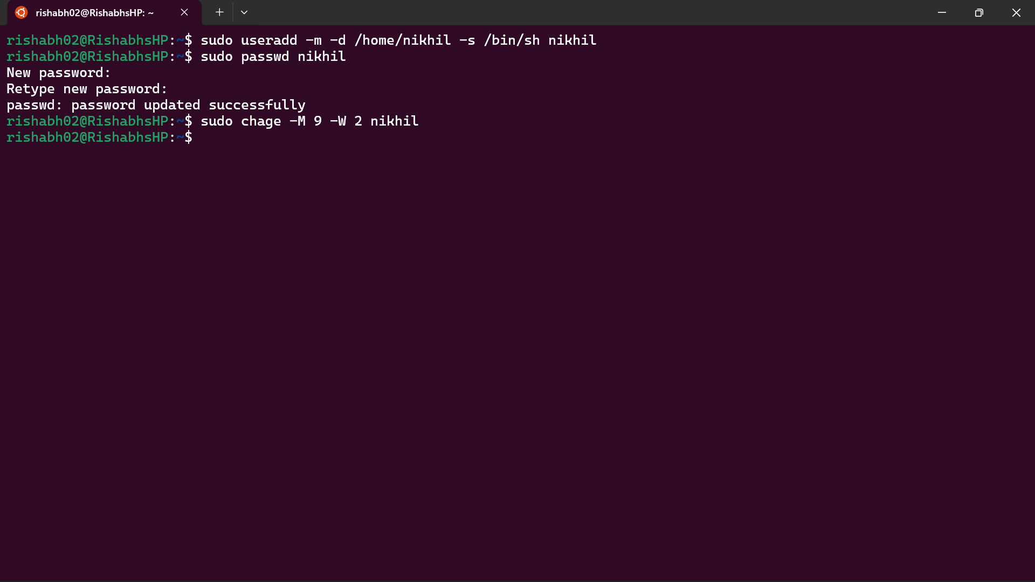

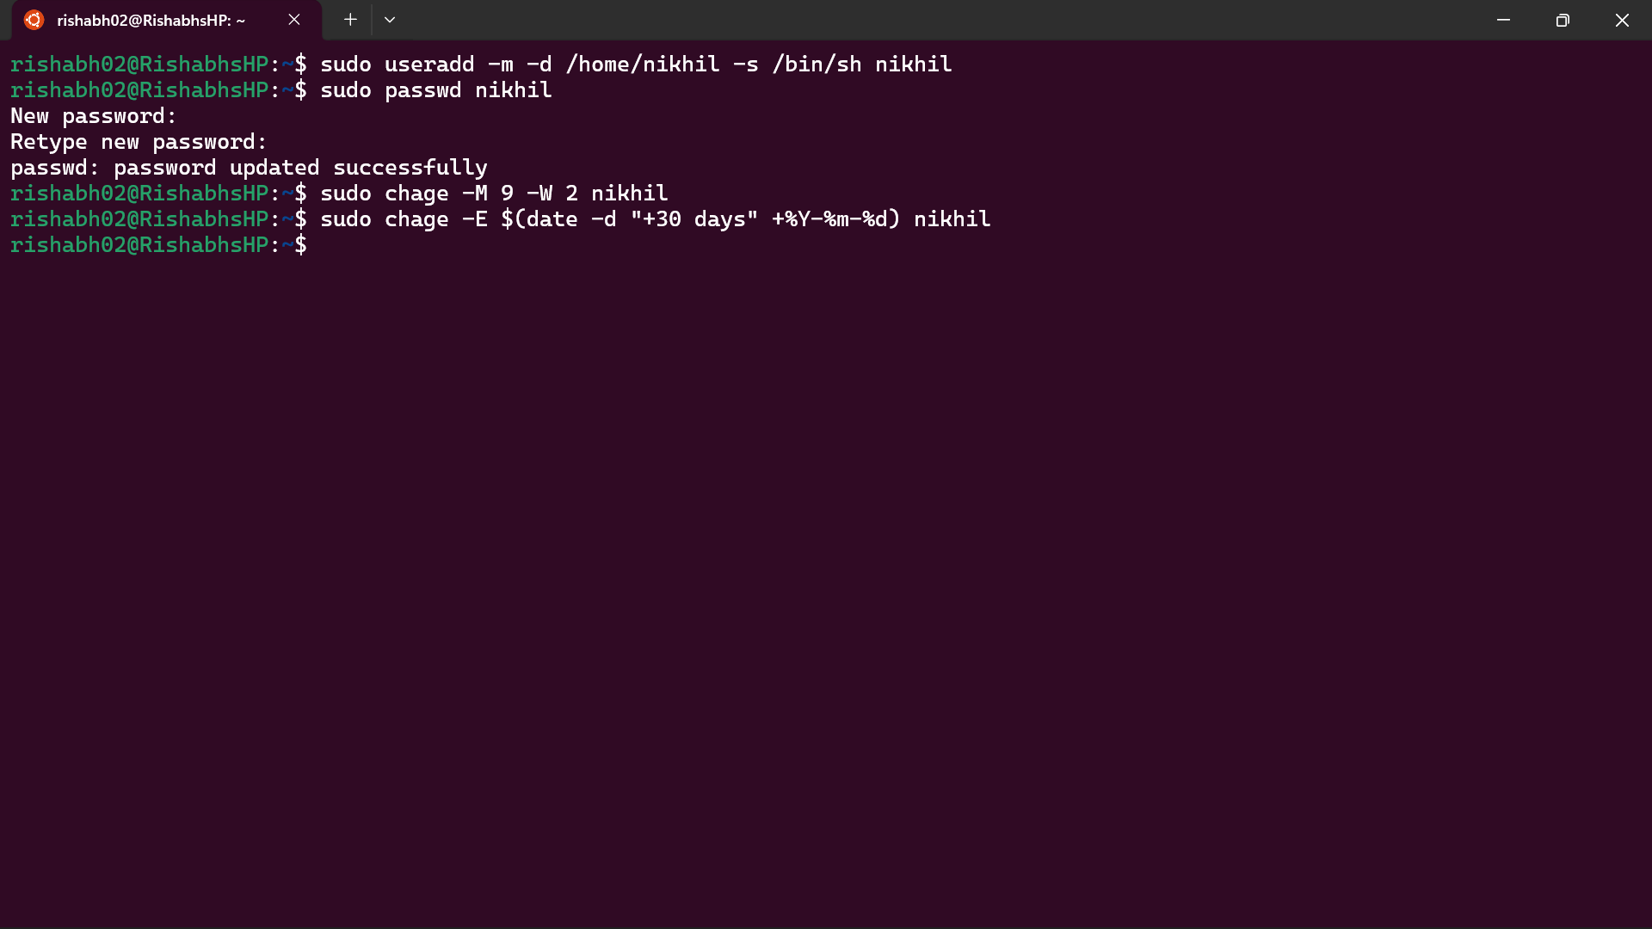

2) Inside folder "/" , create new home directory as "nikhil" (/nikhil) and setup this folder as a home directory for user "nikhil"
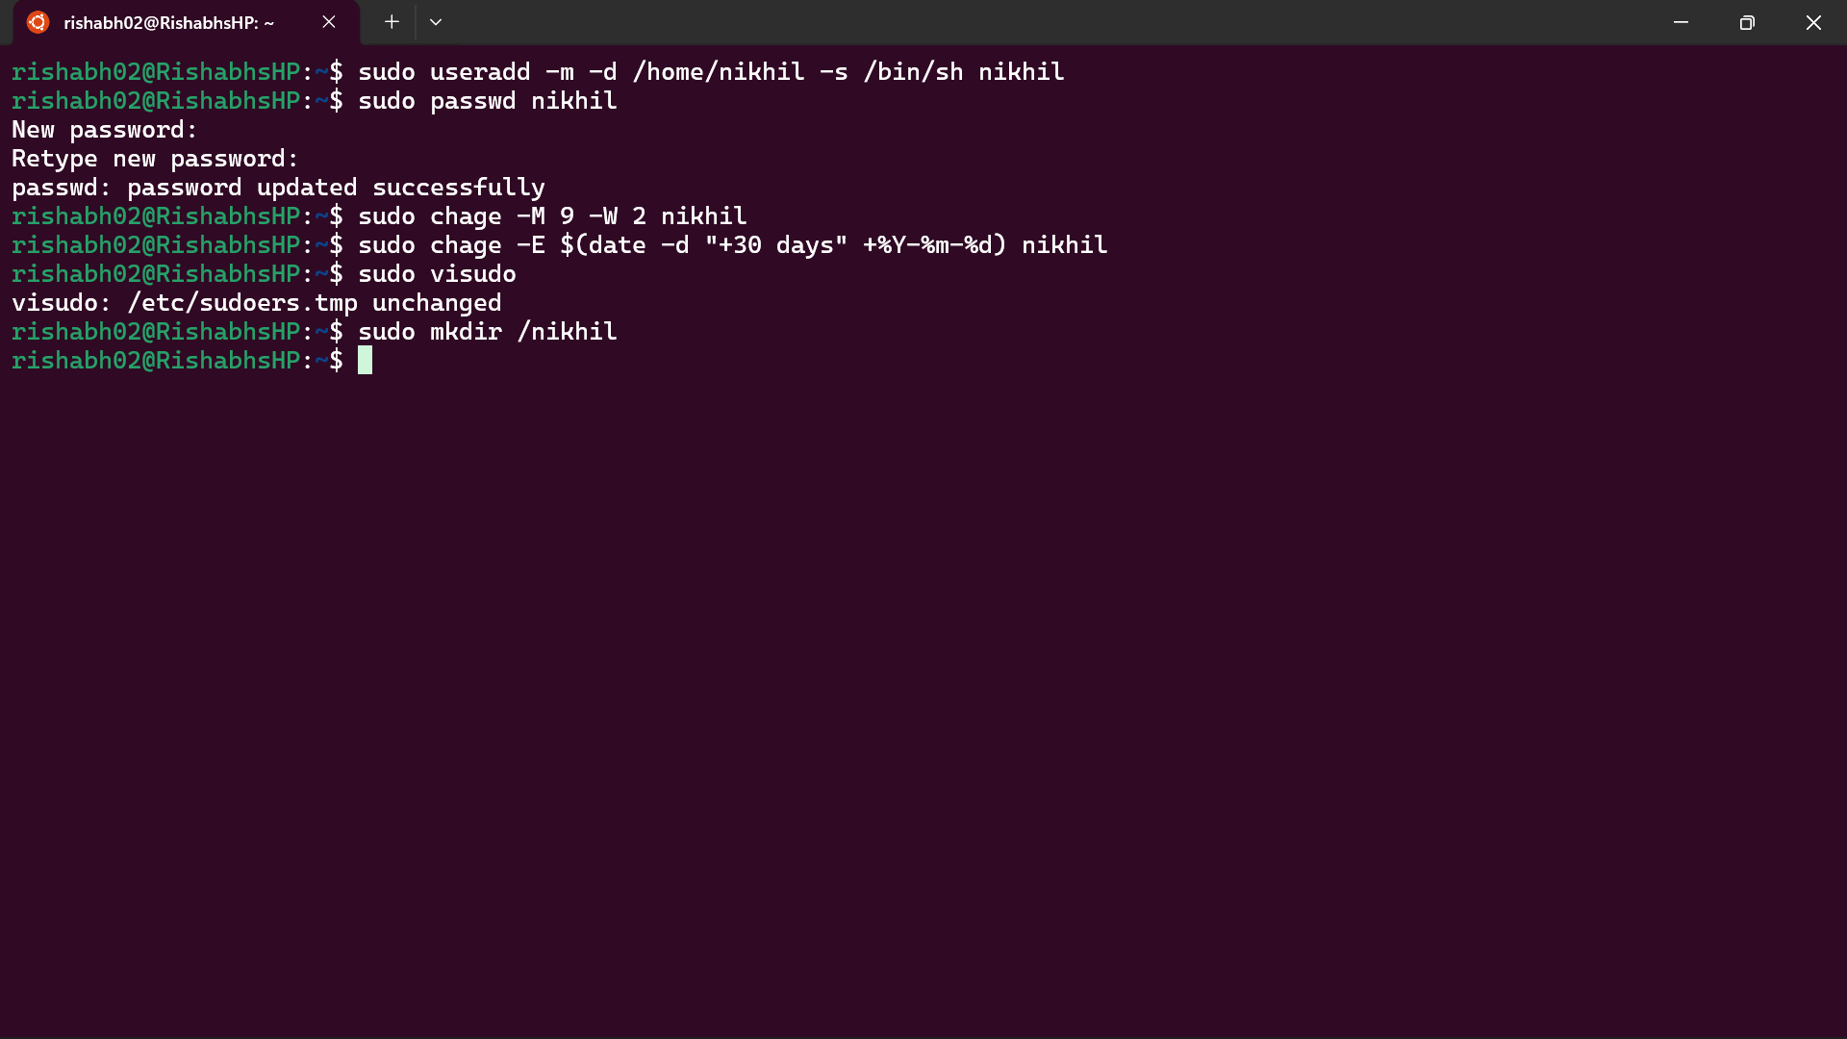

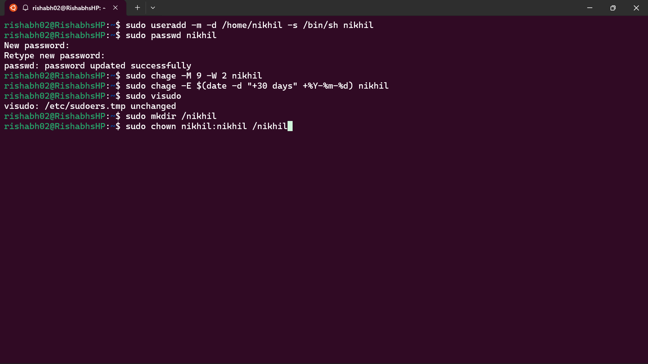

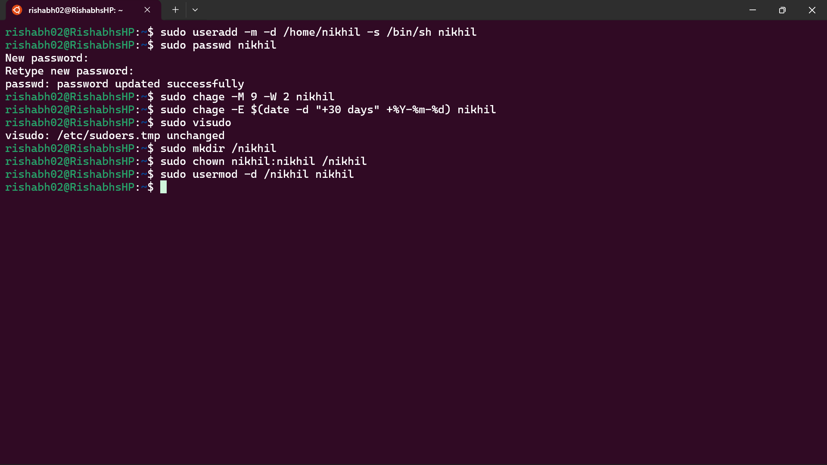

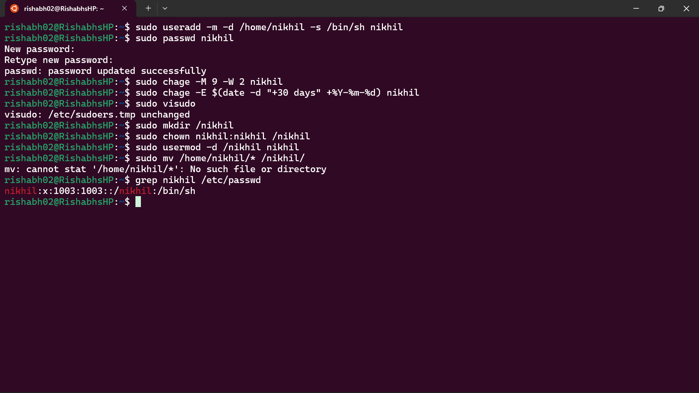

Explanation:-

1) Create user "nikhil" with required configurations

Create user with home directory and shell
Command:
sudo useradd -m -d /home/nikhil -s /bin/sh nikhil
Explanation:
- -m creates the home directory
- -d /home/nikhil sets the home directory path
- -s /bin/sh sets the default shell

Set password for user
Command:
sudo passwd nikhil

Set password expiry and warning
Command:
sudo chage -M 9 -W 2 nikhil
Explanation:
- -M 9 sets password expiry in 9 days
- -W 2 gives warning 2 days before expiry

Set account expiry (1 month from creation)
Command:
sudo chage -E $(date -d "+30 days" +%Y-%m-%d) nikhil
Explanation:
- Sets account to expire after 30 days

Give permission to start/stop cron service
Command:
sudo visudo
Add the following line:
nikhil ALL=(ALL) NOPASSWD: /usr/sbin/service cron start, /usr/sbin/service cron stop
Explanation:
- Allows user to start and stop cron service with root privileges
- Does not give full sudo access

2) Create new home directory /nikhil and assign to user

Create directory
Command:
sudo mkdir /nikhil

Change ownership
Command:
sudo chown nikhil:nikhil /nikhil

Change user's home directory
Command:
sudo usermod -d /nikhil nikhil

Move existing data (optional)
Command:
sudo mv /home/nikhil/* /nikhil/

Verify configuration
Command:
grep nikhil /etc/passwd
Expected output:
nikhil:x:1001:1001::/nikhil:/bin/sh

